

CVC “Reimagining Engagement” Symposium
April 20, 2022
Agenda

8:30 AM Arrivals, Networking and Continental Breakfast

9:00 AM Symposium Begins

    - Welcome – Cheryl Kortemeier, Executive Director, CVC
    - 30th Anniversary Kick-off – Reina Jones, Delta Community Credit Union, CVC President and Imara Canady, AIDS Healthcare Foundation, CVC Vice President
    - Greetings from Atlanta Metropolitan State College – Dr. Georj Lewis
    - Special Reading – Ms. Maliyah Smith, Student, AMSC
    - Morning Discussion:
The Environmental Social Governance (ESG) Framework and How it Relates to Corporate Social Responsibility (CSR) - Sydney Langdon, Senior Director of CSR, Warner Bros. Discovery and Julia Wilson, Managing Director of Advisory - Strategy, KPMG US

10:00 AM Breakout Sessions

Corporate Volunteering and Service - Planning to support corporate community engagement and nonprofit excellence into the future with Karen Beavor of Georgia Center for Nonprofits, Richard Hicks of Inspiredu, Allison Toller of YMCA of Metro Atlanta and Alice Turner of UPS

Corporate Philanthropy - What's Next for Philanthropy? with Deloitte and a regional philanthropy outlook with Stephen Sherman of Philanthropy Southeast, Nikita Trivedi of Georgia Power, Mandy Burnette of WestRock and Yvonne Whitaker of NCR Corporation

11:00 AM Breakout Sessions Repeat, Participants Change Rooms

12:00 PM Luncheon & Networking

12:30 PM Keynote Address by CB Bhattacharya, Center Director and H.J. Zoffer Chair, Katz Graduate School of Business, University of Pittsburgh and author of Small Actions, Big Difference: Leveraging Corporate Sustainability to Drive Business and Societal Value

1:30 PM Adjourn

Thank you for joining us today!

CVC “Reimagining Engagement” Symposium
April 20, 2022
Sponsors

We are Deeply Grateful for the Support of our Sponsors:

Mother of Pearl Sponsors

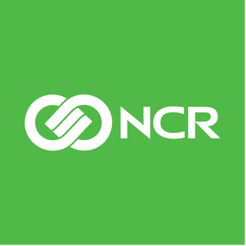


Pearl Earring Sponsors

Alston & Bird

Delta Community Credit Union

Veritiv

The Relationship Between CSR and ESG
CVC “Reimagining Engagement” Symposium, April 20, 2022
Speaker Bios



Sydney Langdon, Senior Director of Corporate Social Responsibility, Warner Bros. Discovery

Sydney Langdon serves as Senior Director of Corporate Social Responsibility at Warner Bros. Discovery where she manages corporate contributions, nonprofit grantmaking and charitable partnerships, as well as employee community engagement and volunteerism. Sydney serves on the board of the Center for Puppetry Arts and as Past President of the Corporate Volunteer Council (CVC) of Atlanta. She is also a member of LEAD Atlanta’s Class of 2016. Sydney holds a Bachelor of Arts degree in English with a concentration in media & communications from the University of Rochester and a Bachelor of Music degree in Vocal Performance from the Eastman School of Music. She also received a Masters of Arts Management from Southern Methodist University and a M.B.A. from SMU’s Cox School of Business. Sydney and her husband, Joel, live on Atlanta’s Westside with their two daughters.

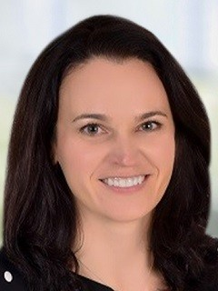

Julia Wilson, Managing Director, Advisory Practice, KPMG and ESG Strategy Leader

Julia Wilson is a Managing Director in KPMG’s Advisory practice. Based in Atlanta, GA, Julia has spent significant time advising clients in the Consumer & Retail industries. As a managing director in the practice, she advises corporate and private equity clients in finding performance improvement opportunities both inside and outside of the deal space.
To support her clients in their transformation and growth agendas, Julia finds ways of marrying traditional research assets and cutting-edge analytics capabilities, data sets and visualization tools to help provide actionable insights.
Julia’s areas of expertise include consumer insights and research, commercial and operational diligence, large scale performance transformation, revenue growth management and pricing, cost takeout and performance optimization, market opportunity analysis and strategic option analysis.
Julia holds a bachelor’s degree from the College of William and Mary and an MBA from the Darden School of Business at the University of Virginia.


Future of Volunteering and Service
CVC “Reimagining Engagement” Symposium, April 20, 2022
Speaker Bios

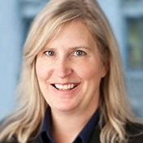

Karen Beavor, President and CEO, Georgia Center for Nonprofits

As President and CEO of the Georgia Center for Nonprofits since 1998, Karen has led GCN’s growth into a leading state association empowering nonprofits through education, advocacy, research, consulting and business support services.
Karen has served as a board member or advisory board member of a variety of civic and nonprofit organizations including the Unemployment Services Trust; National Nonprofit Risk Management Center; and The Foundation Center–Atlanta. Karen has received the Martin Luther King Leadership award and the Harvard Business School Club of Atlanta’s Community Leader Award. She is a member of the 2000 class of Leadership Atlanta and 2003 Coca-Cola Diversity Leadership Academy, and a graduate of Agnes Scott College.

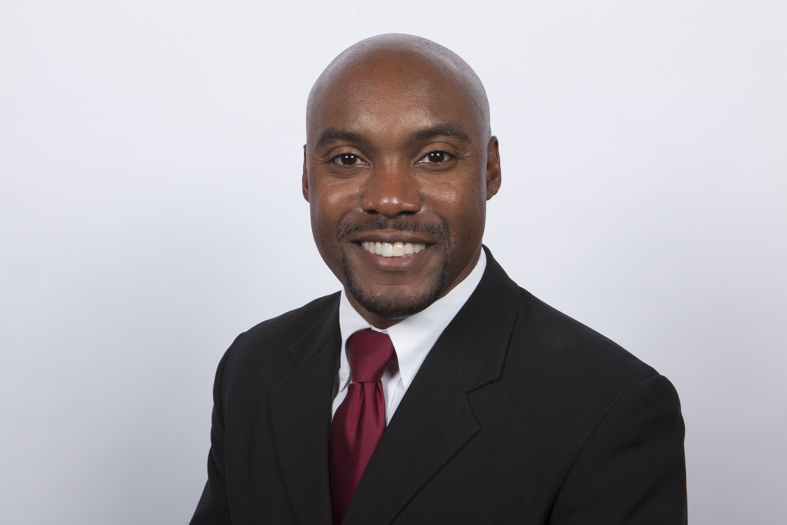
Richard Hicks, CEO & President, Inspiredu

Richard Hicks is the CEO & President of Inspiredu, as well as a transformational nonprofit leader and speaker committed to improving opportunities for children and helping families improve their socioeconomic status. In his 11+ years with Inspiredu, and in his previous roles, Richard has led teams, managed high-dollar projects, and developed growth and fundraising strategies. He has been instrumental in creating relationships and alliances with Fortune 500 companies and with the tech community. Richard has a BA in Information Systems and Communications from Georgia College & State University and serves on the Executive Advisory Board for ATP (Atlanta Technology Professionals) and Advisory Board for Consort Institute at Clark Atlanta University . In addition to his career at Inspiredu, Richard also enjoys volunteering with and supporting other service organizations like the Agape Family and Youth Center. He sees the focus on families and communities as pivotal in our ever-changing world.

Future of Volunteering and Service
CVC “Reimagining Engagement” Symposium, April 20, 2022
Speaker Bios

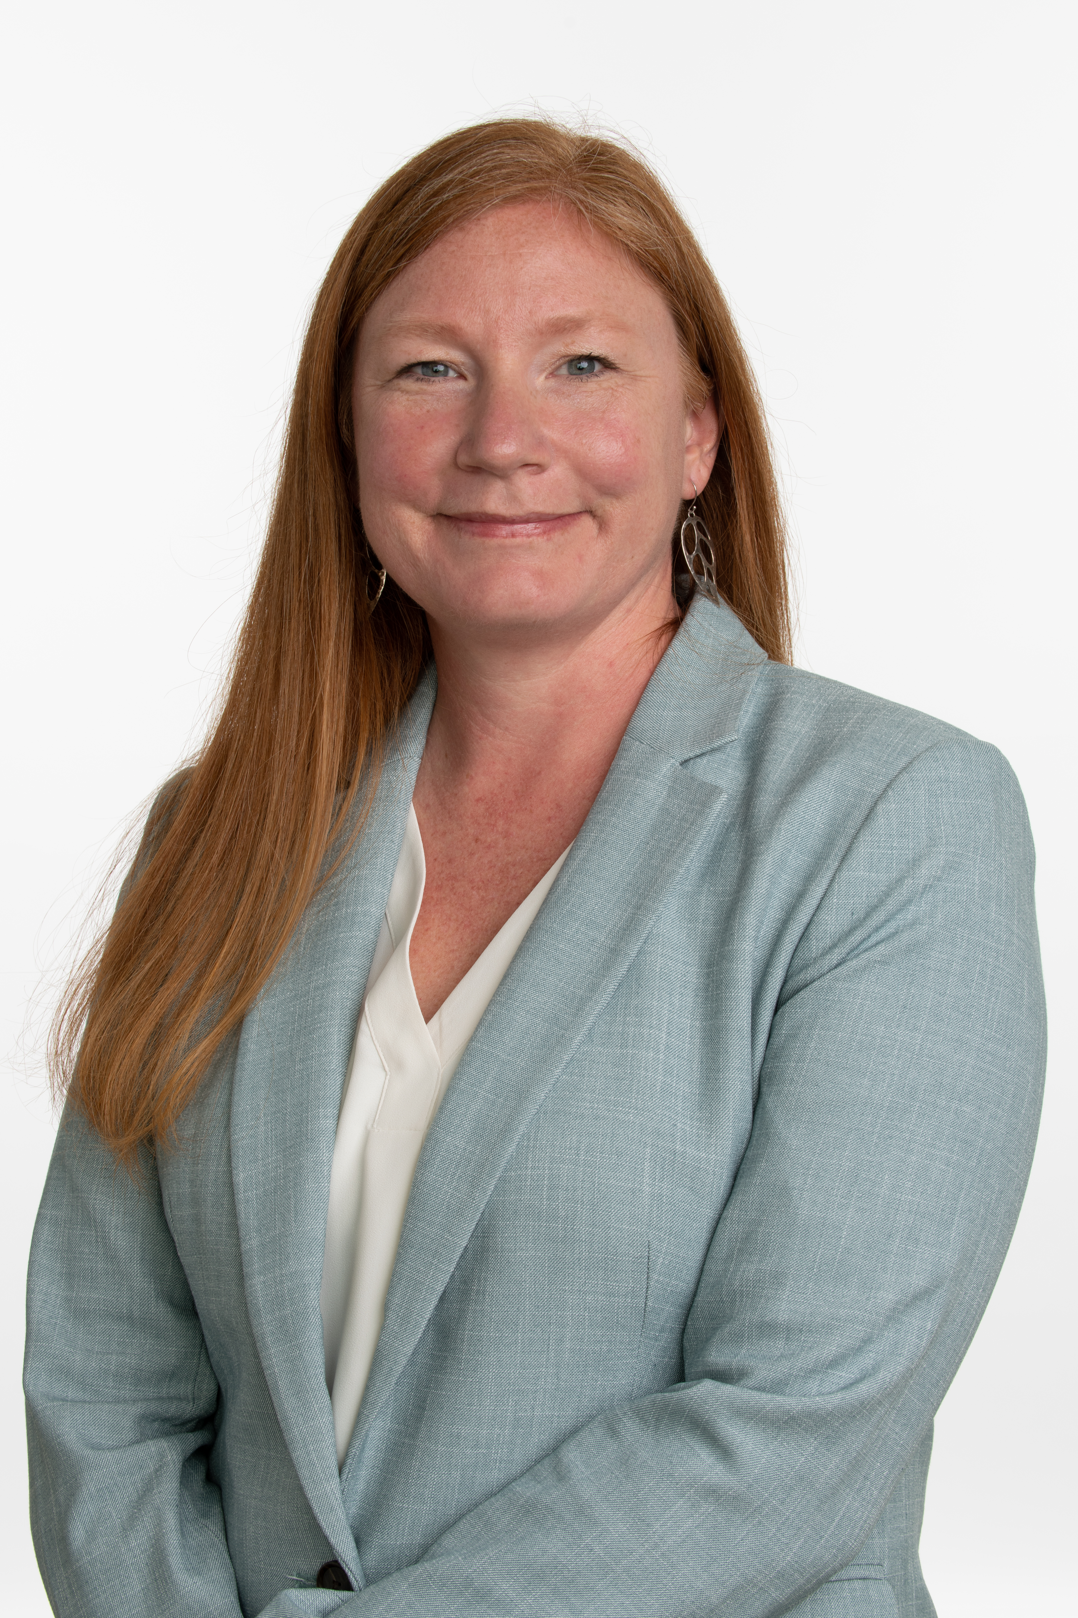

Alice Turner, Manager of Social Impact and the UPS Foundation, UPS

Alice Turner started her career with The UPS Foundation in 2007 and is currently responsible for supporting the UPS Health & Humanitarian Relief & Program, UPS’s Global forestry initiative and UPS Women Exporters Program. With a passion for community, she has a degree in Social Services and worked with multiple grassroots NGOs prior to joining UPS.

Alice coordinates air, ocean and ground shipments across UPS’s global transportation network to bring life-sustaining supplies to disaster survivors and refugee aid agencies. In 2021, The UPS Foundation transported more than 2,000 in-kind shipments across 71 countries, including support for the global refugee crisis and Covid-19 response efforts. She also oversees The UPS Foundation’s Global Forestry Initiative to plant 50 million trees by 2030. In her role with the Women Exporters Program, she works with internal and external partners to provide training and tools for women-owned businesses to thrive in trade.
.

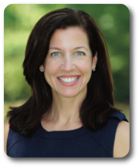
Allison Toller, Chief Social Impact Officer, YMCA of Metro Atlanta
Allison Toller is the Chief Social Impact Officer for the YMCA of Metro Atlanta. Charged with assessing, engaging, and strengthening Y partnerships across non-profit, for profit, and government sectors, she comes to the Y after recently leading Cox Communications' corporate social responsibility strategy.
With a dual background in broadcasting and education, Allison was Chief of Staff and Communications Director for two of the largest school districts in Georgia. Through these experiences, she has a deep knowledge of the education system having led several high profile campaigns on a variety of issues including taxes, teacher shortages, school zoning, and crisis situations.

Future of Corporate Philanthropy
CVC “Reimagining Engagement” Symposium, April 20, 2022
Speaker Bios
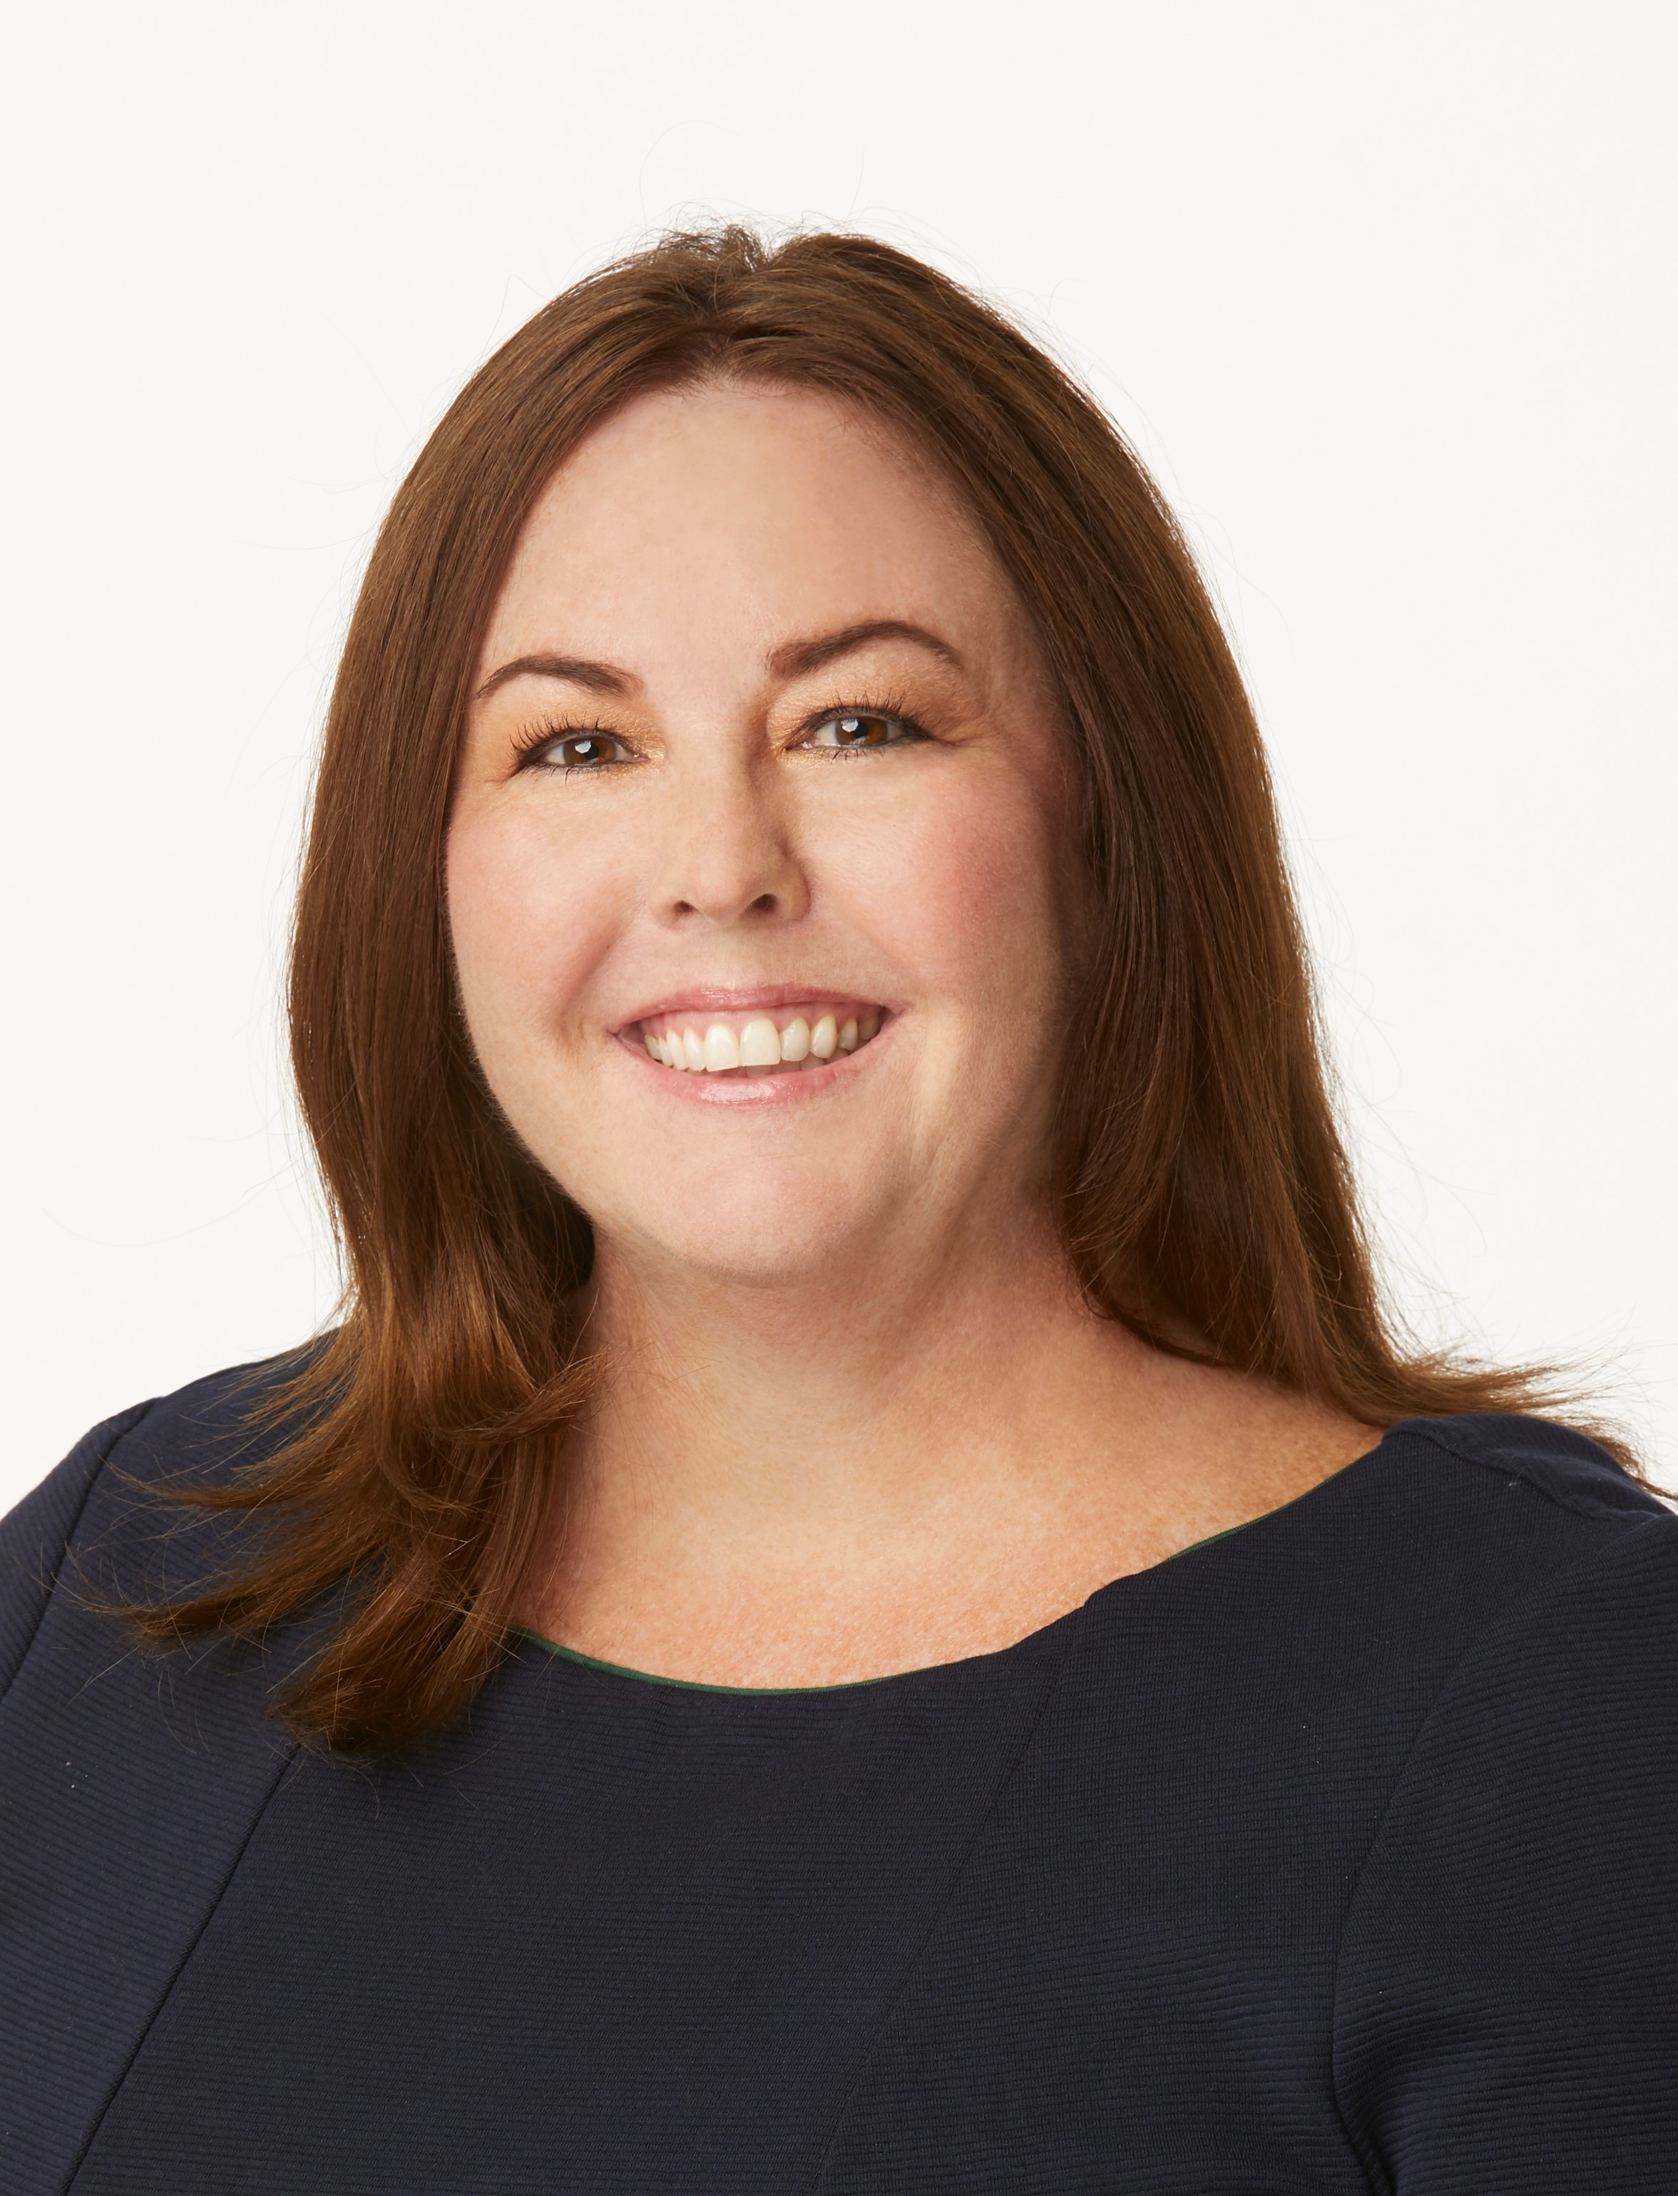

Mandy Burnette, Director of Corporate Giving, WestRock

Mandy Burnette is director, corporate giving for WestRock. In her role she has oversight for community investments and sponsorships across the company, with direct responsibility for managing partnerships in their headquarters community of Atlanta, Georgia. Mandy is also executive director of the WestRock Foundation, overseeing programmatic grant partnerships and employee engagement programs, and the WestRock Employee Relief Fund.

Prior to accepting her corporate giving role, Mandy was a member of the employee communications team at WestRock, focused on leadership communications, employee engagement and strategic projects, including the complete redesign and implementation of a company-wide intranet. Before joining WestRock, Mandy was development director for the Greater Richmond Chamber, and spent 11 years at Ukrop’s Super Markets, managing community sponsorships and public relations.

Mandy earned a bachelor’s in Mass Communications-Public Relations from Virginia Commonwealth University, and is co-convener of Atlanta Corporate Donors participates in the Atlanta Women’s Foundation Inspire Atlanta program, a member of The Woodruff Arts Center Corporate Campaign Cabinet, The Conference Board’s Global CSR & Philanthropy Council, and president of her HOA board.

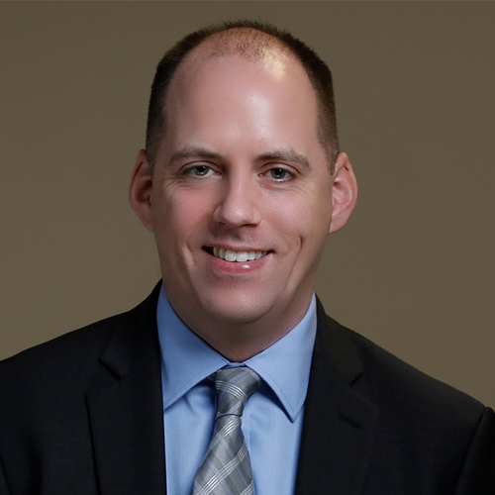

Stephen Sherman, Director of Research and Data, Philanthropy Southeast

Stephen Sherman joined Philanthropy Southeast in 2017 as Research & Data Manager and was named Director of Research & Data in 2020. He supports member engagement and coordinates research initiatives for the organization. Previously, he worked with the Foundation Center's Atlanta office, including serving as Atlanta Lead. In this role, he was responsible for managing the library's collection of materials on fundraising and nonprofit management, providing in-depth resource consultations for patrons, and overseeing the day-to-day operations of the office.

He has been active in the Atlanta community teaching programs on grant seeking and proposal writing and has presented for numerous conferences, nonprofit groups, and library workshops. Stephen also served as the Atlanta office's liaison to the local grantmaking community and has been closely involved in past research initiatives with Philanthropy Southeast and the Georgia Grantmakers Alliance.

Stephen is a member of the Special Libraries Association and enjoys volunteering with a number of other local professional groups and nonprofits. He holds a bachelor’s degree in history from the University of Virginia and a master’s degree in library science from the University of North Carolina at Chapel Hill. Stephen lives just outside Decatur with his wife, Becky, and daughter, Elena.

Future of Corporate Philanthropy
CVC “Reimagining Engagement” Symposium, April 20, 2022
Speaker Bios

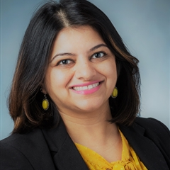

Nikita Trivedi, Director of Corporate Philanthropy, Georgia Power Company

Nikita serves as Director of Corporate Philanthropy for Georgia Power Company. In this role, she oversees company’s Corporate giving strategy, governance, payment, and reporting processes. She manages engagement with major grantees and internal partners across various management council business units.

Nikita has held various leadership roles with increasing responsibilities in areas such as Marketing, Finance, Region Operations and Energy Efficiency at Georgia Power & Southern Company. In the community, Nikita serves on board of National Organizations of Asian Professionals (NAAAP) and Georgia State Alumni Association.

Nikita earned a bachelor’s degree in finance from Georgia State University and a master’s degree from Mercer University. She is a graduate of Leadership Dekalb, Emerging Leaders and Inspire Atlanta.

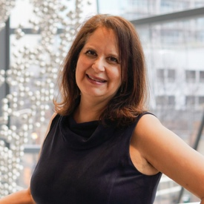

Yvonne Navarro Whitaker, Administrator, NCR Foundation

Yvonne Whitaker currently leads NCR Corporate Foundation; she has been in this role for 10 years. Previously she worked in healthcare, taught at a medical arts college and worked in both nonprofit development and private foundation leadership positions. She currently serves on the board of directors for the Corporate Volunteer Council of Atlanta (CVC) and serves as co-chair of the CVC Governance Committee.

Yvonne grew up in Michigan, raised her family in Ohio and relocated to Atlanta 9 years ago, she currently resides in Chamblee with her husband Mark. She has two Atlanta-based daughters she is incredibly proud of—Casey Navarro works as a comedian, writer and actor and Jordan Whitaker works in a family law practice.

CVC “Reimagining Engagement” Symposium
April 20, 2022
Planning Committee

Symposium Chair

Sara Simonds, Deloitte

30th Anniversary Chair

Imara Canady, AIDS Healthcare Foundation

Committee:

Toccara Arnold Alam, KPMG
Shawan Allen, Cox Enterprises
Kim Beasley, A.G. Rhodes
Michele Egan, Community Volunteer
Geneva Hall-Shelton, IHG
Chaundra Johnson, YMCA of Metro Atlanta
Mary Lee Johnson, Community Volunteer
Reina Jones, Delta Community Credit Union
Cheryl Kortemeier, Corporate Volunteer Council of Atlanta
Kisha Stanley, United Way of Greater Atlanta
Zaneta Taylor, Girl Scouts of Greater Atlanta
Mike Vinciquerra, Trees Atlanta
Yvonne Whitaker, NCR

The Corporate Volunteer Council of Atlanta thanks you for joining us today. You may learn more about CVC membership and view upcoming programming and events any time at https://www.cvcofatlanta.org.

Please follow us on Facebook, Twitter and LinkedIn!

#CVCofAtlanta
#CVCAtlanta30

