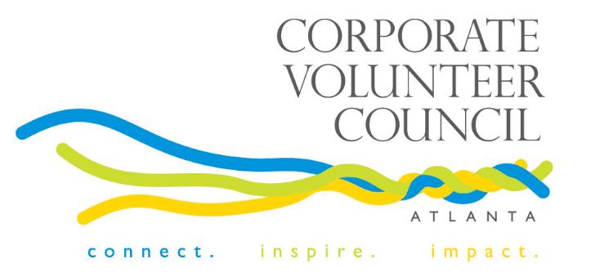

The IMPACT Awards
2016 Sponsorship Opportunities

September26, 2016
11:30 a.m. to 1:30 p.m.
Woodruff Arts Center

Join us at the 19th annual IMPACT Awards to honor the superlative work of corporations that have soared to new heights by engaging employees and sharing their many resources. Discover what some of Atlanta’s most philanthropic companies are doing – from the C-suite to entry-level employees – to tie volunteerism back to bottom-line business results, regardless of size, industry or structure.

The IMPACT Awards are presented by the Corporate Volunteer Council of Atlanta. Since 1992, the Corporate Volunteer Council of Atlanta has supported its members in their strategic commitment to corporate employee volunteerism and civic engagement.

Don’t miss this opportunity! To receive all sponsorship benefits, please let us know of your interest by August 31, 2016.

The IMPACT Awards
The IMPACT Awards will recognize six companies for outstanding achievements in corporate volunteer service (for Atlanta-based work) through the following categories:

IMPACT Corporate Volunteer Program of the Year Award
Presented to an exemplary corporate-employee volunteer program that effectively integrates volunteerism into the company’s business culture. We will recognize a small- to medium-business (less than 1,000 Atlanta employees), as well as a large business (more than 1,001 Atlanta employees).

Partnership IMPACT Award
Presented to a program that demonstrates collaboration between organizations in order to develop innovative, community-based solutions that achieve significant, measurable results. Two companies will be acknowledged in this category, including one for the Business-to-Business IMPACT Award and another for the Business-to-Nonprofit IMPACT Award.

Skills-Based Volunteerism IMPACT Award
Presented to an organization in recognition of its volunteer program that leverages the skills of the company’s employees to build operational capacity of nonprofits.

Project IMPACT Award
Presented to a volunteer project that was completed within one year and achieved significant, measurable results.

The IMPACT Awards

2016 Sponsorship Levels

DIAMOND $16,500

The Diamond (Presenting) Sponsor receives category exclusivity. Thank you to The Home Depot Foundation for the ongoing commitment to the CVC of Atlanta and for presenting the 2016 IMPACT Awards.

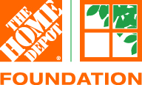

PLATINUM $11,000
Pre-event Visibility:
- Logo recognition on the event invitation
- Recognition in all event press releases
- Recognition on the CVC of Atlanta website
- Invitation to attend the Atlanta Business Chronicle Community Engagement Conversation
- Recognition by the CVC of Atlanta on CVC of Atlanta website, Facebook, Twitter and LinkedIn
Event:
- Two reserved V.I.P. tables of eight at the IMPACT Awards
- Logo recognition in the event program
- Volunteer photos and company logo highlighted in event presentation
- Inclusion on all event signage
Post-event visibility:
- ½ page ad in the October Atlanta Business Chronicle special section on corporate volunteerism (valued at $7,950)
- Company name highlighted as 2016 IMPACT Sponsor in September 30 Atlanta Business Chronicle special section on corporate volunteerism
- Logo recognition on www.cvcofatlanta.org for one year

GOLD $5,500
Pre-event Visibility:
- Name recognition on the event invitation
- Recognition in all event press releases
- Recognition on the CVC of Atlanta website
- Invitation to attend Atlanta Business Chronicle Community Engagement Conversation
Event:
- One reserved V.I.P. table of eight at the IMPACT Awards
- Recognition in the event program
- Volunteer photos and company logo included in event presentation
Post-event visibility:
- ¼ page ad in the October Atlanta Business Chronicle special section on corporate volunteerism (valued at $4,950)
- Company name highlighted as 2016 IMPACT Sponsor in the September 30 Atlanta Business Chronicle special section on corporate volunteerism
- Logo recognition on www.cvcofatlanta.org for one year

SILVER $2,750
Pre-event Visibility:
- Recognition on the CVC of Atlanta website
- Invitation to attend Atlanta Business Chronicle Community Engagement Conversation
Event:
- 4 tickets to the IMPACT Awards
- Recognition in the event program
- Volunteer photos and company name included in event presentation
Post-event visibility:
- 1/8 page ad in the October Atlanta Business Chronicle special section on corporate volunteerism (valued at $3,250)
- Company name highlighted as 2016 IMPACT Sponsor in the September 30 Atlanta Business Chronicle special section on corporate volunteerism
- Logo recognition on www.cvcofatlanta.org for one year

Please contact Cheryl Kortemeier for additional sponsorship opportunities at: cheryl@cvcofatlanta.org or 404-745-2458.
CVC of Atlanta

IMPACT AWARDS

September 26, 2016 – Woodruff Arts Center - 11:30 a.m. to 1:30 p.m.

SPONSORSHIP COMMITMENT FORM

 | LEVEL  (select one) | TOTAL
DIAMOND SPONSOR |  | $ 16,500
PLATINUM SPONSOR |  | $ 11,000
GOLD SPONSOR |  | $ 5,500
SILVER SPONSOR |  | $ 2,750
 | # of TICKETS | TOTAL
Additional Tickets – Sponsors may purchase additional tickets at the member rate of $75 per ticket. |  | $
 | # of TICKETS | TOTAL
Awards Tickets Only (Members) – Single event tickets may be purchased by members at a discounted rate of $75 per person or $600 for a table of eight. |  | $
Awards Tickets Only (Non-Members) – Single event tickets may be purchased by non-members at $125 per person or $1,000 for a table of eight. |  | $
Contribution – We are unable to attend the event, but please accept this donation to support corporate volunteerism in Atlanta. |  | $
TOTAL CONTRIBUTION |  | $

Organization Name
Name as it should appear in print
Contact Person(s)
Address
Phone
Email
Please return completed form by Friday, August 31 to cheryl@cvcofatlanta.org or mail to Ms. Cheryl Kortemeier, Corporate Volunteer Council of Atlanta, 1100 Peachtree Street, NE, Suite 2800, Atlanta, GA 30309.
(Tax ID #: 58-2054790)

Please make checks payable to Corporate Volunteer Council of Atlanta and mail to the address above. For special payment arrangements, please contact Cheryl Kortemeier at cheryl@cvcofatlanta.org or 404-745-2458.

